we can use the delete statement to remove individual records or groups of records from our table at any one time. The fastest way of achieving this is by using the table index.

But note this only applies to standard tables and sorted tables do not hash tables. Only these two types of tables have an index.



We make no use of the header line here. Instead, we just directly address the recording dates of the record we want to delete in the body of the internal table. And with the delete statement, we can also use it inside the loop, they're the same type of syntax.

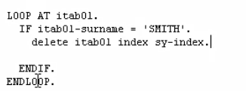

We're going to use the index, but instead of specifying the number, we can use a system variable called sy-index, and when we are inside the loop, this variable gets updated automatically by the system.

One thing to note is that you shouldn't use the delete statement without the index addition. If you went outside the loop, you will be given a run time error, which in turn will cause your program to crash.



there are times when you don't know the actual index of the record that you want to delete. When your table has a non-unique key, you need to use some other logic, to determine which record or records you want to delete.

If the system finds multiple records, all the records will be deleted that match the expression.